Environment Setup - two VM created

VM – 10.0.2.7

VM1 – 10.0.2.6

1. Disable all on VM

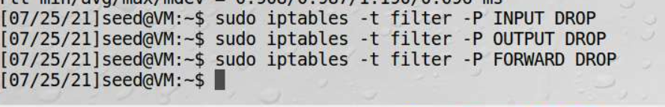

Ping VM1 – failed

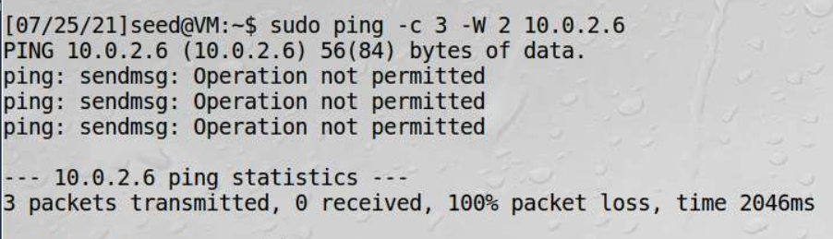

Ping VM from VM1 – failed

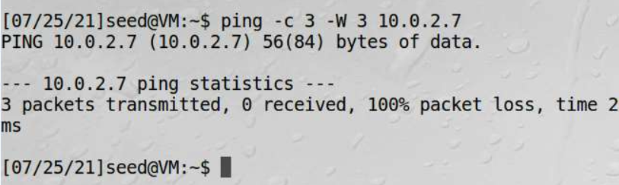

Enable network by executing the same series of commands with DROP replaced by ACCEPT, then ping VM1 from VM - succeeded

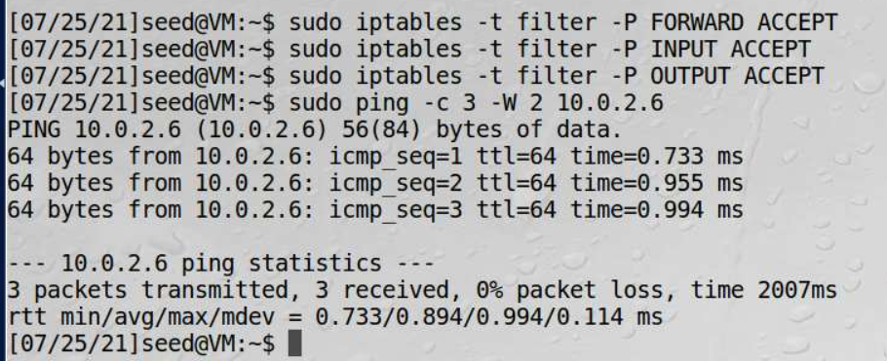

Ping VM from VM1 – succeeded

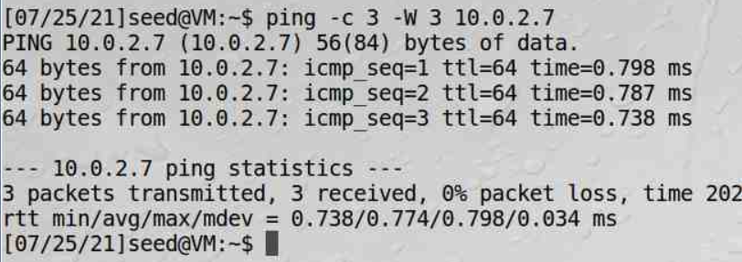

Explanation – at the beginning all actions or packets including INPUT, OUTPUT and FORWARD were disabled/dropped, thus ping between VM and VM1 failed; then while all the packets were allowed, the ping became successful.

1. Blocking an IP

Block packets from VM1



Ping VM from VM1 – failed

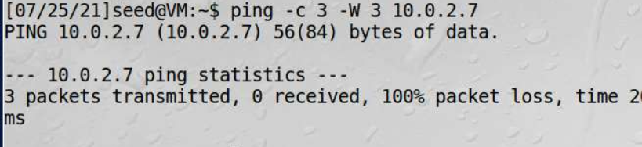

It fails because packets from IP of VM1 was blocked in VM.

Environment setup changed:

VM – 10.0.2.9

VM1 – 10.0.2.8

Block packets to VM1 and ping VM1 from VM, it failed:

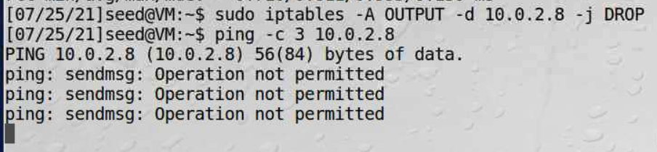

Explanation – as packets blocked from and to IP of VM1, the pings failed.

1. List all rules

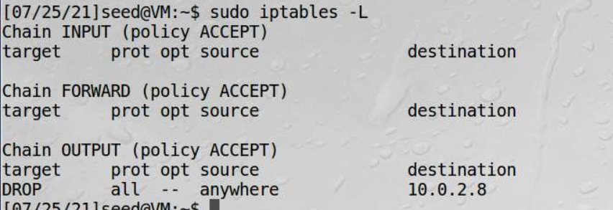

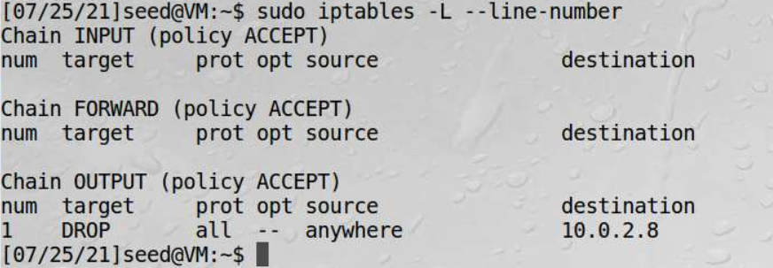

1. Delete a rule – deleted OUTPUT 1 and the rule no longer exists.

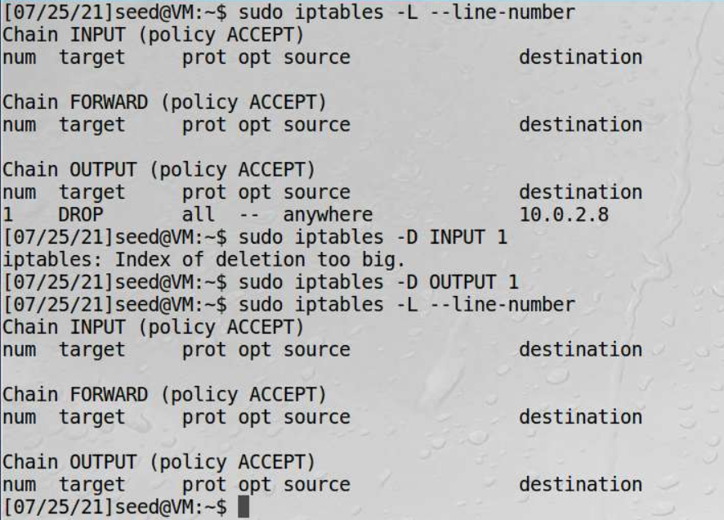

1. Delete all rules in a table [filter]

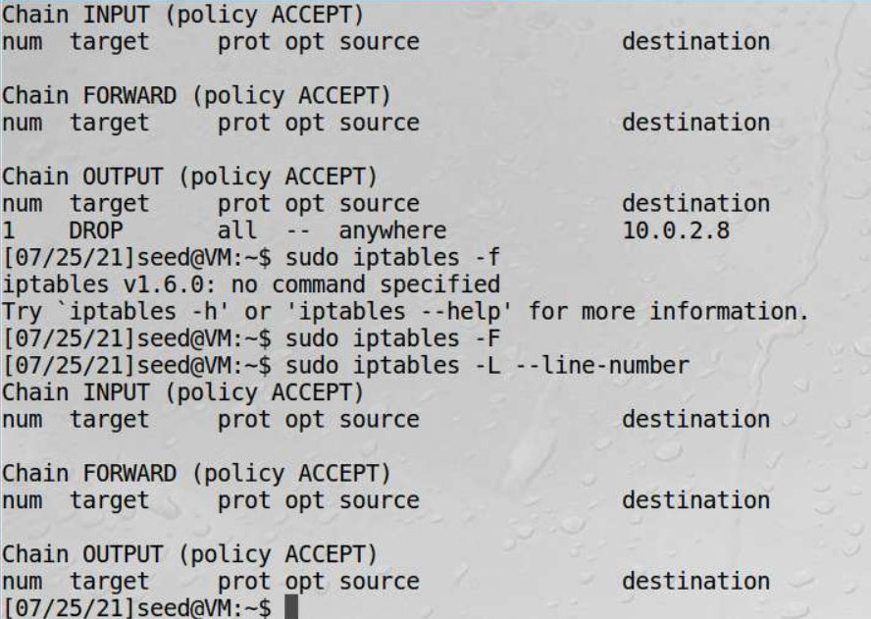

Before delete/flush all rules, there was one rule, afterwards no rule left.

Environment setup changed:

VM – 10.0.2.10

VM1 – 10.0.2.11

1. Drop all incoming connections except SSH (port 22)

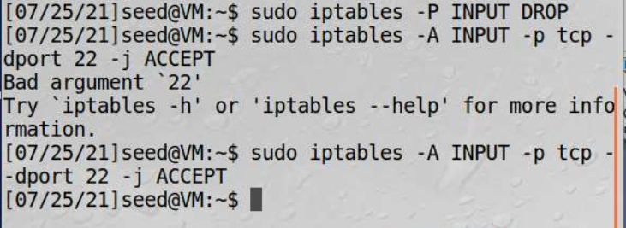

Ping failed   
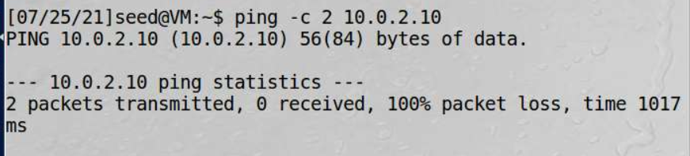

But ssh to VM succeeded

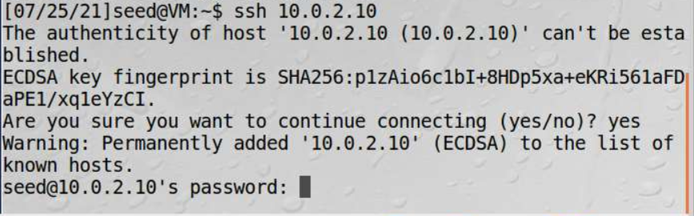

Recover by flush & set to ACCEPT for INPUT

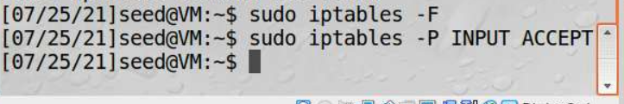

Ping succeeded again:

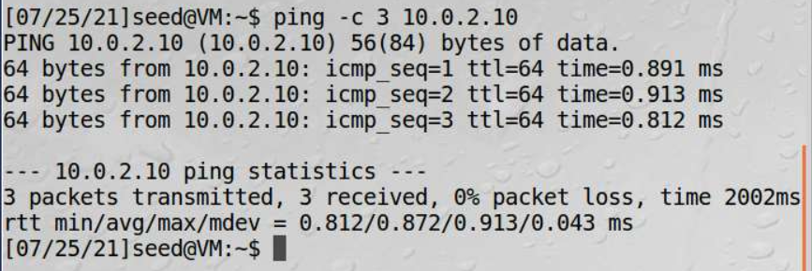

1. Drop outgoing connection to DNS 8.8.8.8

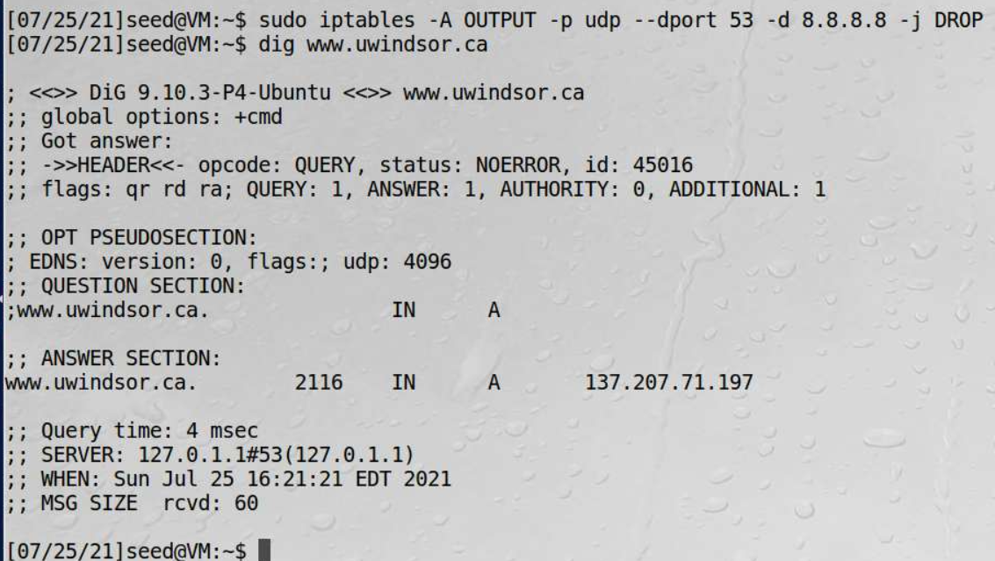

Dig [www.uwindsor.ca](http://www.uwindsor.ca) succeeded, as default DNS server is not the outgoing connection destination denied 8.8.8.8

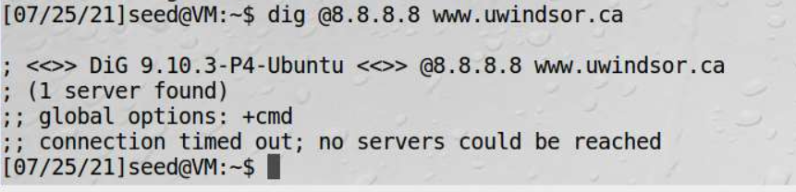

But the dig with DNS server 8.8.8.8 failed, as outgoing to the DNS server was dropped.

1. Block incoming ping request

Delete all rules by flush

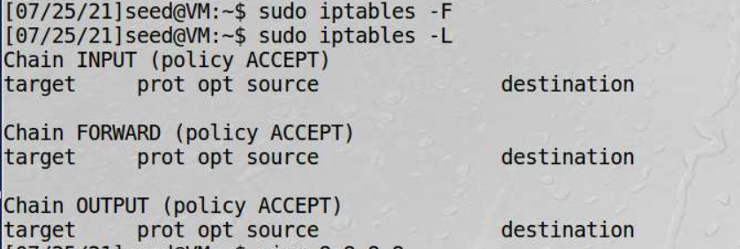

BLOCKED incoming ping request



Ping from VM1, failed

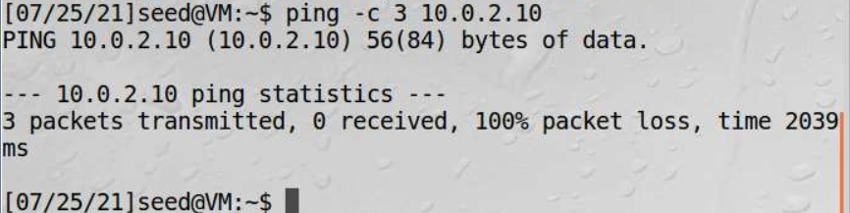

1. Conntrack module

Drop all incoming connections, but open conntrack from VM to VM1, telnet still succeeded to VM1.

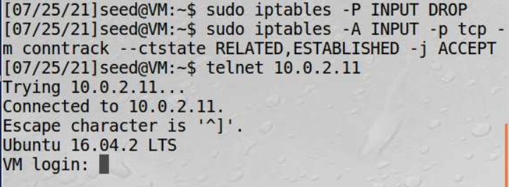

1. Save firewall rules and restore it

Environment setup changed due to connectivity issue:

VM – 10.0.2.12

VM1 – 10.0.2.13

1. Set firewall rules and save to file

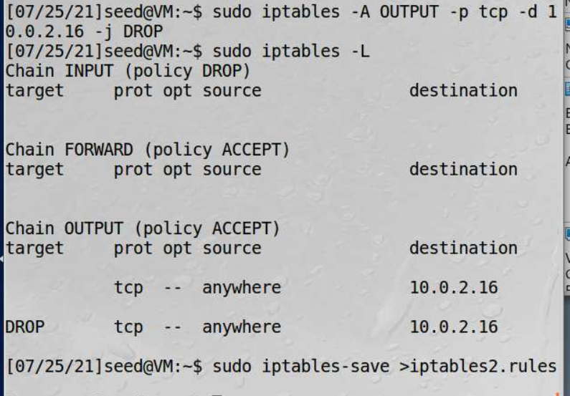

1. Flush all rules 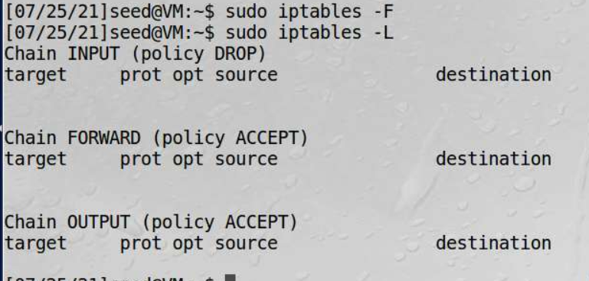

and recover from the rules file, then the iptables rules was restored.

